Your Domestic Violence Safety Plan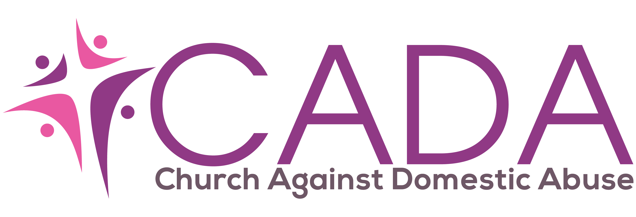

Step 1. Safety during a domestic violent incident
ο I can tell ___________________________(neighbours) about the abuse and ask them to call the police if they hear sounds of a violent attack, coming from my house.
ο If violence and abuse is occurring, or is likely to occur, I can move to _________________________________(a room with easy access to an exit). Don't go to the kitchen, bathroom or near possible weapons.
ο The quickest/safest route out of my home is _______________________________ __________________________________________________________________
ο I have practiced escaping in this way
ο The quickest/safest route out of my workplace is ___________________________ __________________________________________________________________
ο I have practiced escaping that way.
ο I have taught my child/ren to use the telephone to call 999 in an emergency.
ο I will carry a phone card, change for a pay phone, and my mobile phone at all times and ensure that there is always credit so I can ring for help in an emergency.
ο I will keep a small amount of money on me in case I need to leave quickly
ο I have told my child/ren to get out of the room/leave the house/run to ___________________________________for help in an emergency.
ο I will use this code word ________________________________for my children, friends, or family to call for help.
ο If I decide to leave, I will go to_________________________________
ο I will keep my purse and car keys at _________________________ in order to leave quickly.
ο I can pack an emergency bag and leave it at _____________________________ _______________________________________so I can leave quickly.
ο I will use my judgement and intuition. If the situation is very serious, I will try and give my partner whatever he/she wants to calm him/her down. It is important that I try to protect my children and myself until we can get out of danger.

Step 2. Safety when getting ready to leave
ο I will keep important documents (birth and marriage certificates, passports, medical cards, benefit books, bank and building society books, rent/mortgage details, driving licence, car registration documents, details of car insurance, immigration documents) or copies at:________________________________________________________________
ο I will leave some extra clothes, personal possessions, medication, cash and spare keys with________________________________________
ο I will open a savings account by __________________(date) to increase my independence. ο Other things I can do to increase my independence are: _____________________________________________________________ ______________________________________________________________
ο The domestic violence national helpline number is 0808 2000 247
ο The local domestic violence helpline number is: 0161636 7525 ο Other numbers for support agencies are: __________________________________________________________________ __________________________________________________________________
ο I can stay with _________________________________________in an emergency ο I can borrow money from ________________________________ in an emergency
ο If I plan to leave I won’t tell my abuser in advance face –to-face, If I want to tell them I will leave or send a note, or call once I am in a safe place.
ο I will ensure that I never tell my abuser where I am staying ο I will review my safety plan every ___________________(time frame) in order to review whether it is still working for me.
ο I will review the plan with ______________________________ (a friend, agency worker, counsellor or advocate.)
ο I will review and rehearse my escape plan every ___________________ (time frame) and practice it with my children.
Step 3. Safety At Home (if not living with the abuser)
ο I can change my door locks, have extra locks installed and put locks on windows. Completed ________________________ (date)
ο I can ask trusted neighbours (if they know my ex partner) to inform me if they see him anywhere near to my home.
ο I can apply for the Sanctuary scheme to be installed at my property
Completed ________________________ (date)
ο I can install smoke detectors and buy fire extinguishers for each floor of my home
Completed ________________________ (date)
ο I can install an outside lighting system that lights up when someone approaches my home. Completed ________________________ (date)
ο I can get a security system e.g. burglar alarm (installed)_______________________________________________ homelink alarm from police (installed) _________(due for removal)_____________ community alarm (installed) ____________________________________________
ο I will always ensure that I am clear which is the quickest escape route (dependent on where we are in the house), and will share this with my children.
ο I will teach my children to dial 999, or to phone a friend or someone close by
ο I will always use 141 before I make a call, but better still I will call 150 (Customer Services for BT) so my number can be withheld at all times.
Completed ________________________ (date)
ο I will tell the people who care for my child/ren, who has permission to pick up them up and that my partner is NOT allowed to. I understand that if my partner has parental responsibility then I will have to get a court order to stop him from being allowed to collect the children from school/nursery.
I will inform the following people: School_____________________________________________________________ Nursery/Childminder__________________________________________________ Babysitter__________________________________________________________
Sunday School______________________________________________________ Teacher____________________________________________________________ And_______________________________________________________________ Others_____________________________________________________________
ο I can apply for a Non Molestation Order to protect myself from future aggression from my abuser. Completed ________________________ (date)
Order expires ______________________(date)
ο I can apply for an Occupation Order to protect myself from future aggression from my abuser. Completed ________________________ (date) Order expires ______________________(date)
ο I will keep copies of these court orders safe in case I need them in an emergency I will keep them _____________________________________________________
ο Other agencies who I have given a copy of my court orders are: ___________________________________________(local police station) __________________________________________(police domestic violence unit) __________________________________________(advice worker/support worker) ο I will tell (and give a copy of) my employer, my religious leader, my friends, my family, children’s school etc and others that I have a court order.
ο If my court order gets destroyed, I know I can go to the court in which it was made and get another copy.
ο If my abuser violates the protection order, I will call the police and report it. I will call my solicitor, my advocate, counsellor, and/ or tell the courts about the violation.
ο If the police do not help, I will call my advocate or my solicitor
ο I will change my mobile phone number
ο I will change my landline number
ο I will get an answer phone to screen calls
ο I will ask for number-withheld calls to be barred from my landline
ο I will stop using joint accounts and close them as soon as is possible
ο I will explain to my children that its important to keep where we live confidential
Step 4. Job and Public Safety
ο I can tell my boss, security, and _______________ at work about this situation.
ο I can ask___________________________________ to help screen my phone calls.
ο I can ask the IT department to change my e-mail address, and whether it is possible to screen out e-mails from my abuser etc.
ο When leaving work I can do the following: _________________________________________________________________ __________________________________________________________________
ο When I am driving home from work and problems arise, I can: __________________________________________________________________ __________________________________________________________________
ο If I use public transportation, I can: __________________________________________________________________ __________________________________________________________________
ο I will shop at different supermarkets and shopping centres at different hours than I did when I was with my partner.
ο I will use a different bank and bank at different hours than I did when I was with my partner.
o I will change the passwords and security questions on all of my internet accounts including banking and social media.
ο I will change any regular appointments that my partner knows about
ο I will alter my routines as much as possible

Step 5. Drug and Alcohol Use.
ο If I am going to use drugs or alcohol, I am going to do it in a safe place with people who understand the risk of violence and who are committed to my safety.
ο I can also _________________________________________________________
ο I can also contact_______________________________ for support to stop/reduce my use of alcohol/drugs. ο If my partner is using, I can ____________________________________________ ο I can also___________________________________________________________
ο To protect my children, I can____________________________________________
Step 6. Emotional Health
ο If I feel depressed and ready to return to a potentially violent situation/ partner, I can call___________________________ for support and help.
ο When I have to talk to my ex partner on the phone I can: ________________________________________________________________ __________________________________________________________________
ο I will use "I can..." statements and I will be assertive with people.
ο I can tell myself "____________________________________________________" when I feel people are trying to control or abuse me. ο I can call the following people and/ or places for support: _______________________________________________________________ _______________________________________________________________
ο Things I can do to make me feel stronger are: __________________________________________________________________ __________________________________________________________________
ο Things I have tried before which make me feel worse are: __________________________________________________________________ __________________________________________________________________
Always keep your safety plan safe and never leave it where it could be found by your abuser. Share this safety plan with a trusted friend or family member, and also with trusted agency workers you are in contact with. If you are happy to do so then give them a copy and then they can work with you to monitor your progress

Adapted for use by CADA

